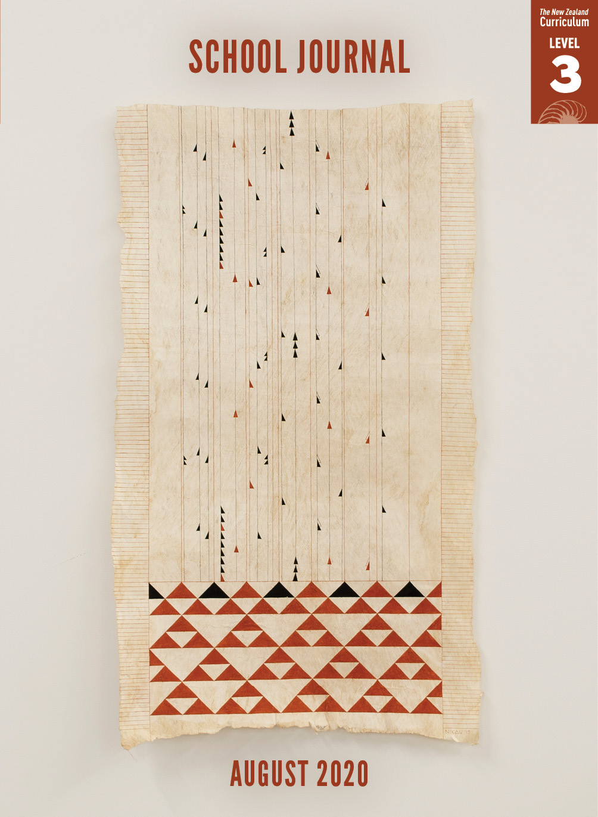

School Journal

Level 3, August 2020

**Year 5**

# Waiting

by Nadine Anne Hura

The[Learning Progression Framework](https://curriculumprogresstools.education.govt.nz/lpf-tool/)s describe significant signposts in reading and writing as students develop and apply their literacy knowledge and skills with increasing expertise from school entry to the end of year 10.

## Overview

This is a gentle story with a twist, which is revealed in the final illustration. While most *School Journal* stories are set over a few hours   
or days, this piece has an unusually long timeframe: nine months. During this time, Bella learns a more positive way to count the days – by noticing the seasons change and trusting that something is happening, even though it may appear otherwise.

A PDF of the text is available at [www.schooljournal.tki.org.nz](http://www.schooljournal.tki.org.nz).

## Themes

|  |  |  |  |
| --- | --- | --- | --- |
| * Change | * Friendship | * Community | * Relationships |

## Related texts

**“Whānau”** SJ L3 May 2019 | **“Koro’s Song”** SJ L3 Aug 2018

## Strengthening reading behaviours (what to notice)

|  |  |
| --- | --- |
| Text structure and features | Requiring students to: |
| * Implied information  *“Are you waiting for anything in particular?”  Bella shrugged. It was complicated. She didn’t want to talk about Mum and Dad and their problems.* * Abstract ideas  *“The seasons, of course,” Rosie said. “You probably think time moves slowly, but if you watch the garden, you’ll see things change every day.”* * Connecting ideas across the text *Now the branches on Bella’s tree were covered in pale pink blossoms. / The spindly branches produced leaves, followed by tiny green fruit.* * Some complex sentences *A few weeks after moving in, Bella was lying on her bed, reading, when she heard Pīata barking.* | * use their own prior experiences and prior knowledge of other texts to infer that Bella is waiting for her dad to come home, and this is the reason for her disquiet * make connections with the friendship between Rosie and Bella and their own experiences, as well as with the way the author has provided clues about this relationship, to interpret the comfort Rosie possibly feels from the passing of seasons that helps her to endure the changes in her life * pay close attention to specific references and clues showing the passing of time, particularly with reference to the seasons, to understand the story’s lengthy time frame * identify the main clause (or idea) and track ideas across several phrases and clauses to gain meaning. |

|  |  |
| --- | --- |
| Vocabulary | |
| Possibly unfamiliar words in te reo Māori (not translated) | Pīata (bright or glossy), Haramai e Pii (Come here, Pii – Haramai is an alternative version of Haere mai),  E kāo (Oh no) |
| Interesting and descriptive vocabulary | unlatched, tentatively, cobbled, frantically, bilingual, drifted, gluggy, crimson, broccoli, feathery, spindly, dusky |

|  |
| --- |
| Helpful prior knowledge (pre-reading and introducing the text) |
| * Experience of waiting for something for a long time * Knowledge of the seasons and the changes in nature |

## Possible reading and writing purposes

* Find out what Bella is waiting for
* Explore the relationship between Bella and her neighbour
* Describe and evaluate the writer’s use of language features and structure
* Identify and analyse the writer’s purpose

See *Effective Literacy Practice in Years 5–8* for information about teaching comprehension strategies ([Teaching comprehension](http://literacyonline.tki.org.nz/Literacy-Online/Planning-for-my-students-needs/Effective-Literacy-Practice-Years-5-8/Teaching-comprehension)) and for suggestions on using this text with your students ([Approaches to teaching reading](http://literacyonline.tki.org.nz/Literacy-Online/Planning-for-my-students-needs/Effective-Literacy-Practice-Years-5-8/Approaches-to-teaching-reading)).

## Possible curriculum contexts

This text has links to level 3 of *The New Zealand Curriculum* in: [**ENGLISH**](http://nzcurriculum.tki.org.nz/The-New-Zealand-Curriculum/English)[**HEALTH AND PHYSICAL EDUCATION**](http://nzcurriculum.tki.org.nz/The-New-Zealand-Curriculum/Health-and-physical-education)

## Understanding progress

The following aspects of progress are taken from the [Learning Progression Framework](https://curriculumprogresstools.education.govt.nz/lpf-tool/)s and relate to the specific learning tasks below. See the LPFs for more about how students develop expertise and make progress in these aspects:

Reading for literary experience

Making sense of text: reading critically

Making sense of text: using knowledge of text structure and features

Using writing to think and organise for learning.

## Strengthening understanding through reading and writing

The *School Journal* provides rich texts that can be returned to many times. The following suggestions are based on the premise that rereading the text is a fundamental part of developing students’ understanding and reading skills. **Select from and adapt** them according to your students’ strengths, needs, and experiences.   
Note: Most of these activities lend themselves to students working in pairs or small groups.

* Ask the students to share times when they have waited for something, such as a birthday or for a friend or family member to return. Discuss how their thoughts and feelings changed over the time that they were waiting: *How does it feel when you get close to what you‘re waiting for? How long is a long time for you? How do you keep track of the time you have left to wait?*
* Before reading, make predictions about what the story will be about based on the title and the illustration on page 2. During reading, encourage the students to update their predictions and make inferences about what will happen next based on evidence from the story.
* Discuss why time is so important to Bella. Have the students look for all the references to time that the author makes and discuss their significance. You could give the students clues about what to look for, such as particular words, illustrations, or references to the seasons. Alternatively, you could brainstorm ways that time can be measured (for example, seasons changing, vegetables growing, pets getting older, and so on) and then have the students look for examples in the text.
* As a group, fill in a Y chart for each of the seasons (what it looks like, what it feels like, what it sounds like). Then ask the students to look for evidence that reveals what season it is in each section of the story. Add this information to the Y chart.
* Have the students use the **Character relationships** template on page 3 of this TSM to explore the relationships between the characters.  You could create a template that the students could add to using [Google Docs](https://www.google.com/docs/about/).
* Identify examples of descriptive language the author uses. Encourage the students to make connections to these words and phrases by sharing what each one reminds them of. Discuss how these descriptions combine to create a sense of place.
* Ask the students to identify which languages the main characters speak and say why each is bilingual. Discuss what we learn about Rosie from this quote: *“Hai. My husband was Japanese. Rosie went quiet. Her smile drifted for a moment.”*
* Take examples of complex sentences used in the story and show how each one is made up of an independent clause (the part that can stand alone as a sentence) and one or more dependent clauses. For example, *When she lay on the bed,* *she could see the branches waving to the grey sky,* includes an independent clause and one dependent clause (the underlined section). Discuss how dependent clauses add details and extra information and how these can make sentences more interesting. Have the students experiment with adding dependent clauses to simple sentences in their own writing.
* Encourage the students to share their responses to the story. *What are the big ideas that the author wants us to take away?* Prompt them to think about the title, the setting, the experiences of the characters, and the way the story begins and ends.
* Have the students write about a time they had to wait for someone or something. Encourage them to use some of the techniques the author uses to hint at the passing of time.

|  |
| --- |
| “Waiting” Character relationships |

|  |  |  |  |  |  |  |
| --- | --- | --- | --- | --- | --- | --- |
| Character | What they are like when we first meet them | | How they develop during the story | | What they are like at the end | |
| What do they say and do? | What does this tell you about them? | What do they say and do? | What does this tell you about them? | What do they say and do? | What does this tell you about them? |
| Bella |  |  |  |  |  |  |
| Rosie |  |  |  |  |  |  |

Summary: Write a statement, motto, or whakataukī about the relationship and how it changed over time. Support what you say about the characters with evidence from their words and actions.